Purus Ultrasonic Cleaner 5 litre for Dental
Purus recognizes the importance to dentists of quality, reliability, and value for money.
Our range of ultrasonic cleaners for dental professionals and staff brings quality product, modern design and the reassurance of warranty protection and service support.
This means that your practice is ensured of a total instrument purification system and the highest quality of sterilization standards which you and your patients deserve.

Ultrasonic Cleaner 5 litre
- Produces ultrasonic frequency electrical signal through the ultrasonic generator, then transforms into the mechanical vibrations of the same frequency by transducer's piezoelectricity inversion effect,
- Produces thousands of small bubbles circle "blasting" to clean items.
- Penetrates surfaces, cracks, small holes of items to get rid of dirt rapidly,
- Ensures total instrument purification.
- Cleans the surface of deep hole, blind hole, convex.
- High efficiency and high precision.
- Made of stainless steel
- Water level automatic alarm system.
- 5 litre capacity
- Ultrasonic Power 120W
- Variable Time Setting 1 – 99 minutes
- Temperature Range 20°C - 80°C

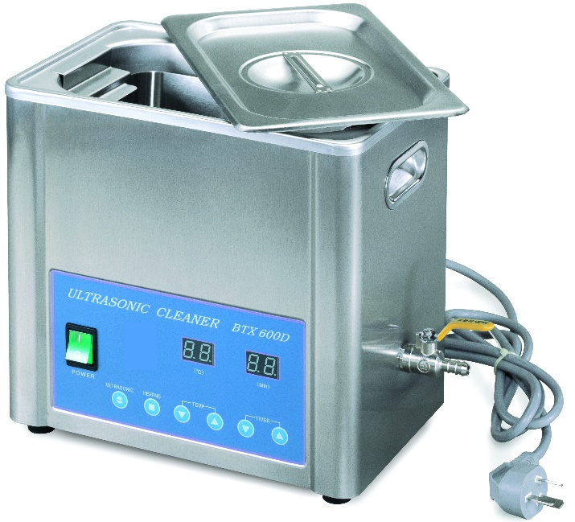
Ultrasonic Cleaner 5 litre

Product Code
purus_UC-105

Product Description

Dimensions
- 24cm L x 14cm W x 15cm H – Internal
- 28cm L x 18cm W x 27cm H -External

Weight
5.5 kg.

Purus Ultrasonic Cleaner 5 litre for Dental

Product Packaging
No assembly required
Ready for use
Complete with internal cleaner basket
Drain tube

Warranty
12 month warranty

Service
Call Purus Now
- To discuss your Ultrasonic Cleaner needs
- For best pricing
- Electrical Tag Test to be completed by a Purus Authorised Service Technician
- Quality and cost effective service supported by warranty
- Repair and Maintenance agreements available

Contact Details

Contact 1300 Purus 9

Unit 4 / 56 Barclay Road, Derrimut VIC 3030

p: +61 3 8358 5557

f: +61 3 8358 5545

e: info@purushealth.com.au

www.purushealth.com.au

Finance
We have a panel of finance providers (including Medfin, Westpac Health, and Investec) and will introduce you to them for a competitive financing package.

