Purus 18L Touch Series 2.0 - B class Autoclave

Purus recognizes the importance of quality, reliability, and value for money.
Our range of autoclaves brings easy-to-use functionality, contemporary styling, technical quality, and the reassurance of warranty protection and service support.
This means that your business can ensure the highest quality of sterilization standards which you and your clients deserve.

18 Litre B class
- LCD display window displays sterilisation process
- Full touch screen.
- High precision, temperature sensors precise to 0.1 degree, pressure sensor accurate to .001bar
- Multiple record output, print USB or SD card
- Stand by setting
- Custom cycle function
- Hand lock door with pressure lock system
- Smart maintenance system
- Water quality test function
- European standard, with 3 times pre and drying vacuum
- Latest design steam generator
- Sterilizing Temp 121°c 134°c
- Sterilizes:
Packed/unpacked solid or hollow items, porous items
Removes air from hollow area of any instrument
- Australian standard AS/NZ 4815-2006, CE
- TGA ARTG Registration No 222444 Class 11B
- Total compliance for your sterilization needs

18 Litre B class Touch Autoclave

Product Code
purus_AC-18Btouch Series 2.0

Product Description

Chamber Size
- Diameter - 245mm
- Depth - 360mm

External dimensions
- 56cm D x 47cm W x 40cm H

Weight
- 50kg.

18L Touch Series 2.0- B class Autoclave

Installation
- Simply plug in and use – self-installed by customer
- Bowie Dick, Vacuum and Helix test Installed
- Accessories supplied:
- USB connection
- chamber rack
- 3 trays
- door spanner
- tray tool
- spare door seal
- level

Service
- Autoclave Calibration / Validation to be completed annually by a Purus Authorised Service Technician
- Quality and cost effective service supported by warranty
- Repair and Maintenance agreements available
- No hidden upkeep service requirements

Warranty
- 3 year back to base warranty on Autoclave

Contact Details

Contact 1300 Purus 9

PO Box 2111, SUNBURY VIC 3429

p: +61 3 8358 5557

e: info@purushealth.com.au

www.purushealth.com.au

Finance
We have a panel of finance providers (including Medfin, Westpac Health, FinLease and Investec) and will introduce you to them for a competitive financing package.

Autoclave calibration graph
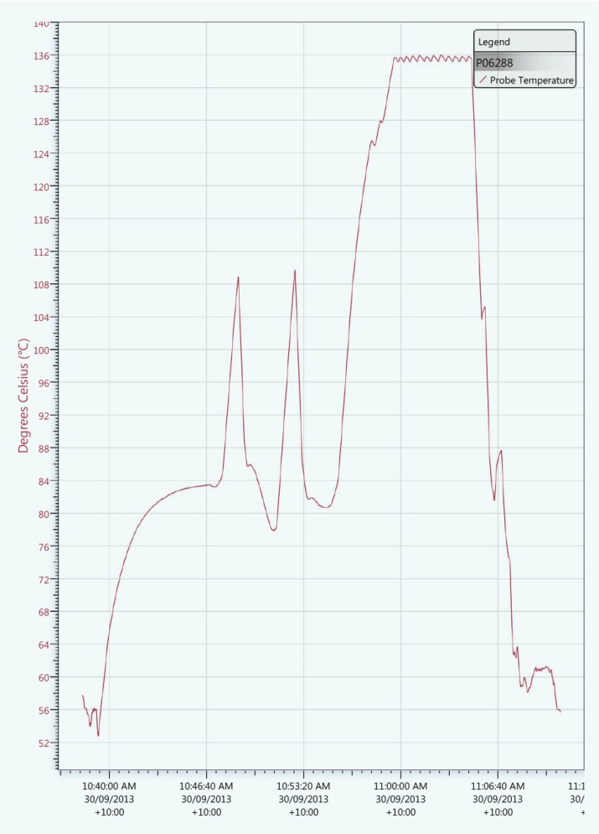
Call Purus Now
- To discuss your Autoclave needs
- For best pricing

